# Tools of the Trade – Lab

We will use lab time today to ensure that your computer is properly set up for IOLab. We will be installing other software throughout the semester as we need it. However, the goal for today is to ensure that you have some of the basic tools that you need to get started.

**Find a partner who is using the same operating system as you and ensure that you have the following software installed.**

## Software Requirements

* Text Editor (Atom or Sublime Text preferred)
* Git
* Python 3
  + Pip
  + Virtualenv

## Instructions

The instructions below are the recommended way of installing this software. If you have your own method for installing software, feel free to do it your own way.

### OSX

**Initial Setup**

xcode-select --install

**Install Package Manager**

The easiest way to install and maintain software on your computer is to use a package manager.

The most popular package manager on OSX is Homebrew. Take a look at the following link and install Homebrew on your machine (<http://brew.sh/>).

*Optionally:* Cask(<https://github.com/caskroom/homebrew-cask>)

You can now use homebrew and homebrew cask to install the remaining software.

**Install Text Editor**

Brew cask install atom

Or

Brew bask install sublime-text3

**Install Git**

Brew install git

**Install Python**

brew install python3

**VirtualEnv**

pip3 install virtualenv

If you are not using Python3

pip install virtualenv

### Windows

**Package Manager**

The most popular package manager on Windows is Chocolatey. However, this community is not as active as Homebrew and I’ve had mixed results with it. You can find installation instructions here: <https://chocolatey.org/>.

If you don’t want to use a package manager, you may install the following items individually by going to each website in the order they are listed below.

**Git**

choco install git

**Text Editor**

choco install atom

Or

choco install SublimeText3

**Command Line**

choco install babun

**Python**

choco install python3

**VirtualEnv**

pip3 install virtualenv

If you are not using Python3

pip install virtualenv

### Ubuntu Linux

**Package Manager**

Apt-get is already comes with the OS.

**Git**

sudo apt-get install git

**Text Editor**

sudo apt-get install sublime-text3

or

sudo apt-get install atom

**Python**

sudo apt-get install python3

**VirtualEnv**

pip3 install virtualenv

**VirtualEnvWrapper**

pip3 install virtualenvwrapper

## Github

We will use Git throughout this class to share code with you and to collect homework from you. Github is a service that makes using git easier and more extensible.

If you don’t already have an account, please sign up for one here: [www.github.com](http://www.github.com).

You will have to set up some keys and files on your computer to allow your computer and Github to communicate with each other.

First, let’s configure some settings: [https://help.github.com/articles/set-up-git/.](https://help.github.com/articles/set-up-git/)

Second, let’s configure some security keys to allow Git and Github to communicate: <https://help.github.com/articles/generating-an-ssh-key/>.

To access the IOLab repository, visit this link: <https://github.com/iolabboys/IOLab>. On the top right hand corner of the page, click on the “Fork” button (top right) to create your own copy of this repo.

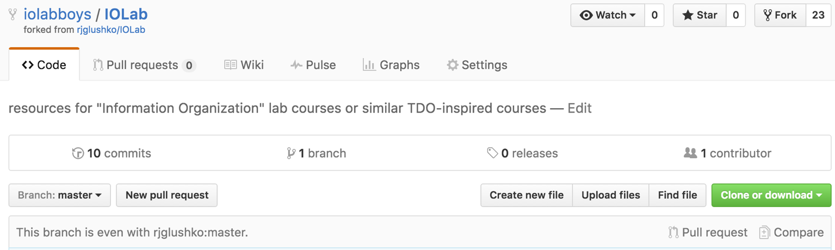

Finally, navigate to the desktop (or, any other convenient location) on your computer using the command line, and clone your newly “forked” repository to your computer. You can do this by using the git clone command and pass it the url to your forked repository like in the example below.

git clone git@github.com:iolabboys/IOLab.git

Ensure that you replace the url above with the url for your own repository. You can find the correct url by navigating your forked repository and copying the ssh url provided (see screenshot below).

